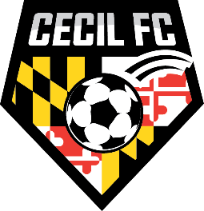

RESTUARANTS NEARBY

Arby's | 224 E. Pulaski Hwy, Elkton, MD 21921
Burger King | 100 W, Pulaski Hwy, Elkton, MD 21921
Chick-fil-A | 1100 E. Pulaski Hwy, Elkton, MD 21921
Cuzino's Family Kitchen | 801 E. Pulaski Hwy, Elkton, MD 21921
Hardee's | 881 E. Pulaski Hwy, Elkton, MD 21921
Jo Jo's Super Dogs | 214 E. Pulaski Hwy, Elkton, MD 21921
McDonalds | 101 E. Pulaski Hwy, Elkton, MD 21921
Pats Pizza | 224 S. Bridge Street, Elkton, MD 21921
Pizza Hut | 350 E. Pulaski Hwy, Elkton, MD 21921
Popeyes Chicken | 106 Big Elk Mall, Elkton, MD 21921
Roma Pizza | 105 Northside Plaza, Elkton, MD 21921
Seasons Pizza | 101 W. Pulaski Hwy, Elkton, MD 21921
Sonic Drive-In | 103 E. Pulaski Hwy, Elkton, MD 21921
Taco Bell | 110 E. Pulaski Hwy, Elkton, MD 21921
Jo Jo's Super Dogs | 2535 Augustine Herman Hwy, Chesapeake City, MD 21915
Maria's Italian Rest. | 2525 Augustine Herman Hwy, Chesapeake City, MD 21915
Chesapeake Pizzeria | 2850 Augustine Herman Hwy, Chesapeake City, MD 21915
Baker's Restaurant | 1075 Augustine Herman Hwy, Chesapeake City, MD 21915

HOTELS NEARBY

Hampton Inn | 2 Warner Road, Elkton, MD 21921
Motel 6 | 223 Belle Hill Road, Elkton, MD 21921
Sunrise Inn | 262 Belle Hill Road, Elkton, MD 21921
Days Inn by Wyndham | 311 Belle Hill Road, Elkton, MD 21921
La Quinta Inn & Suites | 304 Belle Hill Road, Elkton, MD 21921
Holiday Inn Express & Suites | 1570 Elkton, Road, Elkton, MD 21921

