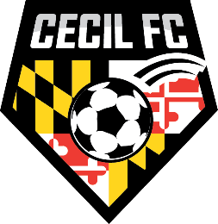

You are invited to the 28th Annual

Chesapeake Cup Soccer Tournament

January 17, 2023

Dear Team Representative:

The Cecil Football Club is again inviting your team to come join us for our spring warm-up tournament the Chesapeake Cup. It is a one-day tournament to be played April 8th. This tournament is open to U-9 through U-16 boys and girl’s teams. The one-day format will give your team three 50-minute competitive games. The outstanding play and the sportsmanship that characterize outstanding soccer will provide plenty of enjoyment for the players and fans alike. The Cecil Football Club plans to make this tournament one your team will enjoy and be proud to attend.

The Chesapeake Cup is a Got Sport Event!!!!!

The Chesapeake Cup Tournament will follow the MSYSA accumulated yellow card policy per section 6 paragraph D of the Tournament Rules. Please review the information carefully and submit your application by March 15, 2023. If you have any questions, please call us at the number listed below. We will be pleased to answer any questions you may have.

Cecil County, Maryland is in the northeast corner of Maryland. Bordering on Pennsylvania and Delaware, right at the head of the Chesapeake Bay. All games are planned to be played at our complex, called Chesland Park, Bo Manor High and North East High, which is easily accessible, by I-95, US Route 40. Cecil County is a one-hour drive from either Philadelphia or Baltimore.

We hope your team will accept our invitation and join us on April 8th for a great day of soccer and fun. We sure you will be glad you did.

Sincerely,

Jeff Privett
Director of Tournaments
410-920-8032
jprivett21@comcast.net

