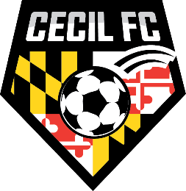CHESAPEAKE CUP SOCCER TOURNAMENT
MEDICAL RELEASE / SCORE KEEPING ACKNOWLEDGEMENT

MEDICAL RELEASE FORMS: This form verifies that I have Medical Release forms for all players playing on my team in this tournament, including guest players. I release the Cecil Football Club, and all participating sponsors, from all responsibility regarding injuries.
SCORE KEEPING: I understand that a team official must sign the Game Card after each match to verify the score and disciplinary action. Once the Game Card is signed, I understand that the score and disciplinary record will be considered accurate and final and will not be changed. Failure to sign the Game Card before leaving the field will also result in the score and disciplinary action to be considered final.
I accept and will abide by the above rules/guidelines/liability on behalf of my team.

TEAM_____________________________________ U______ boys____ girls____

PRINT NAME____________________________________________

SIGN NAME_________________________________________DATE_____________
Forms completed electronically DO NOT require a signature.
Typed names will constitute a signature and agreement with the given statements

