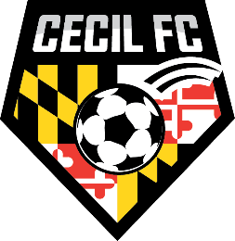

Cecil Football Club is pleased to present its “28th Annual Chesapeake Cup”
We cordially invite your team to our 2023 spring warm-up one-day format tournament.

Tournament Date is April 8, 2023

The Chesapeake Cup is a GotSport Scheduler event! GotSport points will be awarded per GotSport age group guidelines.

You can submit your application electronically to us at the following link
https://system.gotsport.com/event_regs/05a8188ac4
- 3 – 50 Minute Games Guaranteed
- The tournament is an “Unrestricted Tournament” that is open to USYSA, US Club, CMSA and SAY soccer teams.
- Awards will be given to the 1st and 2nd place finishers in each age group bracket.
- U-9 through U-16 boys and girls
- U-9 and U-10 age groups play 7v7
- U-11 and U-12 teams will play 9v9
- Five guest players per team will be allowed. Your guest players cannot bring your roster size over the maximum allowed for your age group.
- Deadline for submitting applications and fees is
March 15, 2023.

Tournament fees are the following:
$500.00 for U-9/U-10 teams and $550.00 for U-11 thru U-16 teams
($50.00 per team discount for any club sending 5 teams)

Tournament information and forms can be found on our web site
www.cecilsoccer.org/tournaments/
Jeff Privett
410-920-8032
jprivett21@comcast.net

