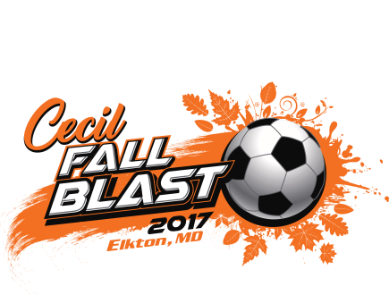

October 31, 2017

Dear Coach:

On behalf of the Cecil Fall Blast Soccer Tournament committee, we would like to acknowledge your acceptance to the tournament and welcome you to what we hope will be a great day of soccer.

Tournament headquarters, registration, and 10 of the 13 fields will be located at our soccer complex “Chesland Park”.
Address is 401 Elk Forest Road, Elkton, MD 21921.
All games are being played Saturday, November 11th. Registration will be held Saturday morning November 11th beginning at 7:00 am and ending at 10:00 am. Registration will also be available on Friday, November 11th from 3:00 pm to 6:00 pm for any teams wishing to register the day before. It is recommended you try and register your team on Friday evening to avoid the rush on Saturday morning. At registration you will need the following:

- Two (2) copies of either you’re stamped state approved roster, US Club roster, or SAY Soccer roster.
- Player Passes for all participating players and guest players (This includes secondary rostered players)
- Medical Release forms for all participating players and guest players

NO EXCEPTION TO ANY OF THESE REQUIREMENTS WILL BE MADE.

We will retain a copy of item 1, review and return items 2 and 3. We will then return 1 copy of the roster with the “Cecil Soccer Approved” stamp to present to the field marshal at each game.

If you wish to register by email I will need your email with your scanned Roster, Player Cards (only front of card) and Medical Releases by Wednesday November 8th. Please note also need player card and medical release for your guest players.
If everything is approved, I will send back to you your stamped approved roster to take to the field marshals.

Schedules can be accessed on Got Soccer:
http://events.gotsport.com/events/Default.aspx?eventid=61635
Enclosed are field locations and directions and a copy of the tournament rules. Please note that all teams must have team captains report to the field marshal 15 minutes before each game for the coin flip and submission of the “Cecil Soccer Approved” roster. There will be minimal time between games requiring all teams to warm-up off the field of play before games. Team patch exchange is encouraged following each game.

All games will be played at Calvert Park and “Chesland Park” home to the Cecil Soccer League complex opened 11 years ago. Located at 401 Elk Forest Road, Elkton, MD 21921.

At Chesland Park only park in the designated parking spaces (no parking on the grass)

Car-Pooling is recommended for teams playing at Chesland Park, as the parking will be tight with 50 teams playing there.

NO GRILLS OR GENERATORS ARE ALLOWED AT EITHER CHESLAND PARK OR CALVERT PARK

Tournament headquarters at “Chesland Park” will house the tournament officials, registration, and lost and found.

There will be Concessions / Refreshments at Chesland Park.

Tee-Shirt sales and other apparel will be for sale at Chesland Park. Fine Designs Imprinted Sportswear will imprint your purchase right on site with what you choose to have on it. They will have available for purchase tee shirts, long sleeve shirts, sweat shirt hoodies, sweat pants, etc...

Standing boards will be stationed at all venues for the teams playing at such venue.

Trophies / Awards will be presented to the 1st and 2nd place teams in each age group by division for all age groups. Trophy presentations will be conducted at venue your team is playing at.

Tournament information and schedules can also be found on our web site.
http://www.cecilsoccer.org/tournaments/fall-blast-2017/
The tournament committee reserves the right to change field location and game schedule if the need arises. You will be notified by a phone call or email of any schedule changes prior to Friday, November 10, 2017

Remember to mark your calendars for our spring 2018 tournament the,
“23rd Annual Chesapeake Cup” to be played March 31, 2018”.

If you have any questions you may contact us at the phone number indicated below. Again, welcome to Cecil County and The 9th Annual Cecil Fall Blast Soccer Tournament. We wish all teams and players the best of luck.

Jeff Privett - Tournament Director & Registrar - (410) 920-8032

