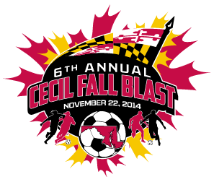

CECIL FALL BLAST
SATURDAY, NOVEMBER 22, 2014

U-15 GIRLS ( 11 V 11 )
CECIL FIRE
HFC UNITED LAZERS
PMSC PENN LANCO UNITED
PIPELINE S.C. RED

 | FIELD | AGE | HOME | VISITOR
7:30 AM | 4 | U-15 G | CECIL FIRE | HFC UNITED LAZERS
8:30 AM | 4 | U-15 G | PMSC PENN LANCO UNITED | PIPELINE S.C. RED
10:30 AM | 4 | U-15 G | CECIL FIRE | PMSC PENN LANCO UNITED
11:30 AM | 4 | U-15 G | HFC UNITED LAZERS | PIPELINE S.C. RED
1:30 PM | 4 | U-15 G | HFC UNITED LAZERS | PMSC PENN LANCO UNITED
2:30 PM | 4 | U-15 G | PIPELINE S.C. RED | CECIL FIRE

REVISED 11/11/14

