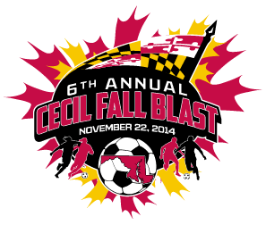

CECIL FALL BLAST
SATURDAY, NOVEMBER 22, 2014

U-14 GIRLS ( 11 V 11 )
CECIL EXPLOSION
FRUITLAND S.C. TIGERS
CECIL FURY
KSC ARSENAL

 | FIELD | AGE | HOME | VISITOR
9:30 AM | 1 | U-14 G | CECIL FURY | KSC ARSENAL
9:30 AM | 2 | U-14 G | FRUITLAND S.C. TIGERS | CECIL EXPLOSION
11:30 AM | 1 | U-14 G | FRUITLAND S.C. TIGERS | CECIL FURY
11:30 AM | 2 | U-14 G | CECIL EXPLOSION | KSC ARSENAL
1:30 PM | 1 | U-14 G | FRUITLAND S.C. TIGERS | KSC ARSENAL
1:30 PM | 2 | U-14 G | CECIL EXPLOSION | CECIL FURY

REVISED 11/11/14

