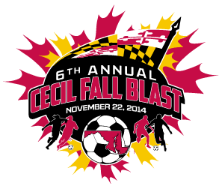

CECIL FALL BLAST
SATURDAY, NOVEMBER 22, 2014

U-13 GIRLS ( 11 V 11 )
KSC JAGUARS
MSI FLAMES
SCCSA DRAGONS
RIVER S.C. SPIRIT-RIPTIDE

 | FIELD | AGE | HOME | VISITOR
9:30 AM | 7 | U-13 G | KSC JAGUARS | MSI FLAMES
9:30 AM | 8 | U-13 G | SCCSA DRAGONS | RIVER S.C. SPIRIT-RIPTIDE
11:30 AM | 7 | U-13 G | MSI FLAMES | SCCSA DRAGONS
11:30 AM | 8 | U-13 G | RIVER S.C. SPIRIT-RIPTIDE | KSC JAGUARS
1:30 PM | 7 | U-13 G | MSI FLAMES | RIVER S.C. SPIRIT-RIPTIDE
1:30 PM | 8 | U-13 G | SCCSA DRAGONS | KSC JAGUARS

REVISED 11/11/14

