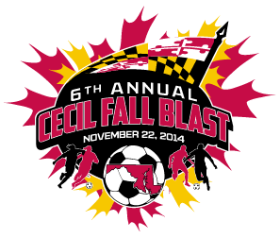

CECIL FALL BLAST
SATURDAY, NOVEMBER 22, 2014

U-12 GIRLS ( 8 V 8 )
CECIL STORM
KSC ECLIPSE
HENLOPEN RIPTIDE
CHESAPEAKE F.C. ACADEMY

 | FIELD | AGE | HOME | VISITOR
7:30 AM | 3C | U-12 G | CECIL STORM | KSC ECLIPSE
8:30 AM | 3C | U-12 G | HENLOPEN RIPTIDE | CHESAPEAKE F.C. ACADEMY
10:30 AM | 3C | U-12 G | CHESAPEAKE F.C. ACADEMY | CECIL STORM
11:30 AM | 3C | U-12 G | KSC ECLIPSE | HENLOPEN RIPTIDE
1:30 PM | 3C | U-12 G | KSC ECLIPSE | CHESAPEAKE F.C. ACADEMY
2:30 PM | 3C | U-12 G | CECIL STORM | HENLOPEN RIPTIDE

REVISED 11/12/14

