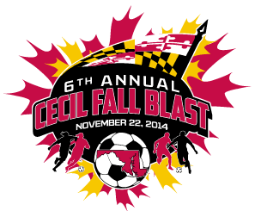

CECIL FALL BLAST
SATURDAY, NOVEMBER 22, 2014

U-11 GIRLS ( 8 V 8 )
CECIL EXPRESS
KSC FLASH
HFC HERRICANES
WASHINGTON TWP PANTHERS

 | FIELD | AGE | HOME | VISITOR
7:30 AM | 6A | U-11 G | CECIL EXPRESS | KSC FLASH
8:30 AM | 6A | U-11 G | HFC HERRICANES | WASHINGTON TWP PANTHERS
10:30 AM | 6A | U-11 G | KSC FLASH | HFC HERRICANES
11:30 AM | 6A | U-11 G | WASHINGTON TWP PANTHERS | CECIL EXPRESS
1:30 PM | 6A | U-11 G | KSC FLASH | WASHINGTON TWP PANTHERS
2:30 PM | 6A | U-11 G | HFC HERRICANES | CECIL EXPRESS

REVISED 11/11/14

