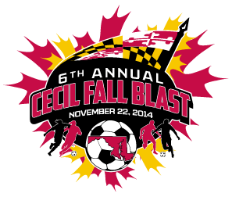

CECIL FALL BLAST
SATURDAY, NOVEMBER 22, 2014

U-10 GIRLS ( 7 V 7 )
CECIL DYNAMITE
MSI KENSINGTON CHEETAHS
ASA BLAST
FALLSTON FIREBALLS

 | FIELD | AGE | HOME | VISITOR
7:30 AM | 6C | U-10 G | CECIL DYNAMITE | FALLSTON FIREBALLS
9:30 AM | 6C | U-10 G | MSI KENSINGTON CHEETAHS | ASA BLAST
11:30 AM | 6B | U-10 G | FALLSTON FIREBALLS | MSI KENSINGTON CHEETAHS
11:30 AM | 6C | U-10 G | ASA BLAST | CECIL DYNAMITE
1:30 PM | 3A | U-10 G | CECIL DYNAMITE | MSI KENSINGTON CHEETAHS
1:30 PM | 3B | U-10 G | ASA BLAST | FALLSTON FIREBALLS

REVISED 11/11/14

