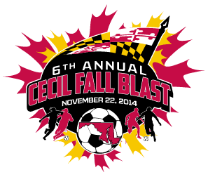

CECIL FALL BLAST
SATURDAY, NOVEMBER 22, 2014

U-16 BOYS ( 11 V 11 )
CECIL ARSENAL F.C.
KSC ELITE
BAYSHORE OSPREYS
ROCKVILLE SOCCER CLUB

 | FIELD | AGE | HOME | VISITOR
7:30 AM | 5 | U-16 B | CECIL ARSENAL F.C. | KSC ELITE
8:30 AM | 5 | U-16 B | BAYSHORE OSPREYS | ROCKVILLE SOCCER CLUB
10:30 AM | 5 | U-16 B | ROCKVILLE SOCCER CLUB | CECIL ARSENAL F.C.
11:30 AM | 5 | U-16 B | KSC ELITE | BAYSHORE OSPREYS
1:30 PM | 5 | U-16 B | KSC ELITE | ROCKVILLE SOCCER CLUB
2:30 PM | 5 | U-16 B | BAYSHORE OSPREYS | CECIL ARSENAL F.C.

REVISED 11/11/14

