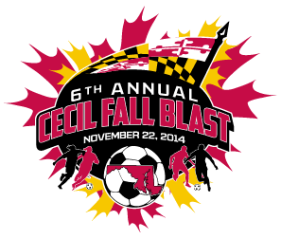

CECIL FALL BLAST
SATURDAY, NOVEMBER 22, 2014

U-14 BOYS BLACK ( 11 V 11 )
CECIL CYCLONES BLACK
FRUITLAND S.C. RED BULLS
BRANDYWINE UNITED THE QUAKE
BAYSHORE REVOLUTION WHITE

 | FIELD | AGE | HOME | VISITOR
9:30 AM | 4 | U-14 B | BRANDYWINE THE QUAKE | BAYSHORE REVOLUTION WHT
9:30 AM | 5 | U-14 B | CECIL CYCLONES BLACK | FRUITLAND S.C. RED BULLS
12:30 PM | 4 | U-14 B | BAYSHORE REVOLUTION WHT | CECIL CYCLONES BLACK
12:30 PM | 5 | U-14 B | FRUITLAND S.C. RED BULLS | BRANDYWINE THE QUAKE
3:30 PM | 4 | U-14 B | BAYSHORE REVOLUTION WHT | FRUITLAND S.C. RED BULLS
3:30 PM | 5 | U-14 B | CECIL CYCLONES BLACK | BRANDYWINE THE QUAKE

U-14 BOYS RED ( 11 V 11 )
CECIL CYCLONES RED
RIVER RUSH 2 BLACK
ELLICOTT CITY CHELSEA BLUE
WEST-MONT UNITED S.C. UNION

 | FIELD | AGE | HOME | VISITOR
8:30 AM | 7 | U-14 B | CECIL CYCLONES RED | ELLICOTT CITY CHELSEA BLU
8:30 AM | 8 | U-14 B | RIVER RUSH 2 BLACK | WEST-MONT S.C. UNION
10:30 AM | 7 | U-14 B | WEST-MONT S.C. UNION | CECIL CYCLONES RED
10:30 AM | 8 | U-14 B | ELLICOTT CITY CHELSEA BLUE | RIVER RUSH 2 BLACK
12:30 PM | 7 | U-14 B | CECIL CYCLONES RED | RIVER RUSH 2 BLACK
12:30 PM | 8 | U-14 B | ELLICOTT CITY CHELSEA BLUE | WEST-MONT S.C. UNION

REVISED 11/11/14

