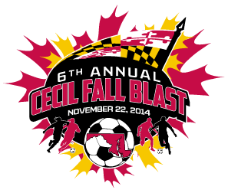

CECIL FALL BLAST
SATURDAY, NOVEMBER 22, 2014

U-13 BOYS ( 11 V 11 )
GROUP 1 | GROUP 2
CECIL GALAXY | MRM RUSH NERO
CAROLINE UNITED | FRUITLAND S.C. SOUNDERS
LANCHESTER UNITED STORM | BAYSHORE BLUE DEVILS

 | FIELD | AGE | HOME | VISITOR
8:30 AM | 1 | U-13 B | CECIL GALAXY | LANCHESTER UNITED STORM
8:30 AM | 2 | U-13 B | FRUITLAND S.C. SOUNDERS | BAYSHORE BLUE DEVILS
10:30 AM | 1 | U-13 B | LANCHESTER UNITED STORM | CAROLINE UNITED
10:30 AM | 2 | U-13 B | MRM RUSH NERO | FRUITLAND S.C. SOUNDERS
12:30 PM | 1 | U-13 B | CAROLINE UNITED | CECIL GALAXY
12:30 PM | 2 | U-13 B | BAYSHORE BLUE DEVILS | MRM RUSH NERO
2:30 PM | 1 | U-13 B | GROUP 1 - 1ST PLACE | GROUP 2 - 1ST PLACE
2:30 PM | 2 | U-13 B | GROUP 1 - 2ND PLACE | GROUP 2 - 2ND PLACE
3:30 PM | 1 | U-13 B | GROUP 1 - 3RD PLACE | GROUP 2 - 3RD PLACE

REVISED 11/11/14

