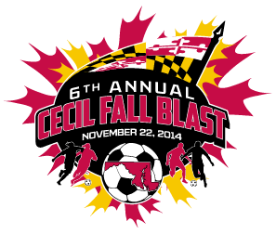

CECIL FALL BLAST
SATURDAY, NOVEMBER 22, 2014

U-12 BOYS ( 8 V 8 )
CECIL ARSENAL F.C.
LANCHESTER UNITED THUNDER
BAYSHORE REAL SHORE
NEYSA BOBCATS

 | FIELD | AGE | HOME | VISITOR
9:30 AM | 3C | U-12 B | CECIL ARSENAL F.C. | LANCHESTER UNT THUNDER
9:30 AM | 6A | U-12 B | BAYSHORE REAL SHORE | NEYSA BOBCATS
12:30 PM | 3C | U-12 B | NEYSA BOBCATS | CECIL ARSENAL F.C.
12:30 PM | 6A | U-12 B | LANCHESTER UNT THUNDER | BAYSHORE REAL SHORE
3:30 PM | 3C | U-12 B | NEYSA BOBCATS | LANCHESTER UNT THUNDER
3:30 PM | 6A | U-12 B | BAYSHORE REAL SHORE | CECIL ARSENAL F.C.

REVISED 11/11/14

