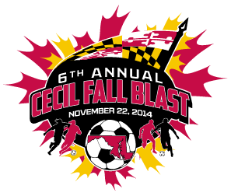

CECIL FALL BLAST
SATURDAY, NOVEMBER 22, 2014

U-11 BOYS ( 8 V 8 )
GROUP 1 | GROUP 2
CECIL STRIKERS | FRUITLAND S.C. REVOLUTION
FRUITLAND S.C. UNITED | MRM ACADEMY BLACK ‘03
LANCHESTER UNITED STRIKER | BAYSHORE UNITED

 | FIELD | AGE | HOME | VISITOR
7:30 AM | 3B | U-11 B | CECIL STRIKERS | LANCHESTER UNITED STRIKER
8:30 AM | 3B | U-11 B | MRM ACADEMY BLACK '03 | BAYSHORE UNITED
9:30 AM | 3B | U-11 B | FRUITLAND S.C. UNITED | CECIL STRIKERS
10:30 AM | 3B | U-11 B | BAYSHORE UNITED | FRUITLAND S.C. REVOLUTION
11:30 AM | 3B | U-11 B | LANCHESTER UNITED STRIKERS | FRUITLAND S.C. UNITED
12:30 PM | 3B | U-11 B | FRUITLAND S.C. REVOLUTION | MRM ACADEMY BLACK '03
2:30 PM | 3B | U-11 B | GROUP 1 - 1ST PLACE | GROUP 2 - 1ST PLACE
3:30 PM | 3B | U-11 B | GROUP 1 - 2ND PLACE | GROUP 2 - 2ND PLACE
3:30 PM | 6B | U-11 B | GROUP 1 - 3RD PLACE | GROUP 2 - 3RD PLACE

REVISED 11/11/14

