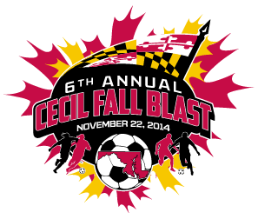

CECIL FALL BLAST
SATURDAY, NOVEMBER 22, 2014

U-10 BOYS ( 7 V 7 )
GROUP 1 | GROUP 2
CECIL SOUNDERS | FRUITLAND S.C. BLAST
FRUITLAND S.C. GUNNERS | SFC STORM
KSC THUNDER | KSC STORM

 | FIELD | AGE | HOME | VISITOR
7:30 AM | 3A | U-10 B | KSC THUNDER | CECIL SOUNDERS
8:30 AM | 3A | U-10 B | FRUITLAND S.C. BLAST | KSC STORM
9:30 AM | 3A | U-10 B | FRUITLAND S.C. GUNNERS | KSC THUNDER
10:30 AM | 3A | U-10 B | SFC STORM | FRUITLAND S.C. BLAST
11:30 AM | 3A | U-10 B | CECIL SOUNDERS | FRUITLAND S.C. GUNNERS
12:30 PM | 3A | U-10 B | KSC STORM | SFC STORM
2:30 PM | 3A | U-10 B | GROUP 1 - 1ST PLACE | GROUP 2 - 1ST PLACE
2:30 PM | 6C | U-10 B | GROUP 1 - 2ND PLACE | GROUP 2 - 2ND PLACE
3:30 PM | 3A | U-10 B | GROUP 1 - 3RD PLACE | GROUP 2 - 3RD PLACE

REVISED 11/11/14

