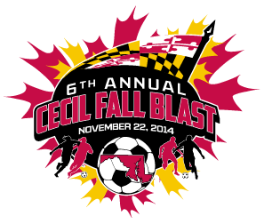

CECIL FALL BLAST
SATURDAY, NOVEMBER 22, 2014

U- 9 BOYS ( 7 V 7 )
CECIL SPIRIT
FRUITLAND S.C. ARSENAL
SCCSA FIRE
KSC HURRICANES

 | FIELD | AGE | HOME | VISITOR
7:30 AM | 6B | U- 9 B | CECIL SPIRIT | SCCSA '05 FIRE
8:30 AM | 6B | U- 9 B | FRUITLAND S.C. ARSENAL | KSC HURRICANES
10:30 AM | 6B | U- 9 B | KSC HURRICANES | CECIL SPIRIT
10:30 AM | 6C | U- 9 B | SCCSA '05 FIRE | FRUITLAND S.C. ARSENAL
1:30 PM | 6B | U- 9 B | CECIL SPIRIT | FRUITLAND S.C. ARSENAL
1:30 PM | 6C | U- 9 B | KSC HURRICANES | SCCSA '05 FIRE

REVISED 11/12/14

